Table of Contents

Contents

CHAPTER 1 2

INTRODUCTION 2

1.1 Background of the Study 2

1.2 Problem Statement 3

1.3 Objectives of the Study 4

1.4 Significance of the Study 5

1.5 Scope and Limitations of the Study 5

1.6 Definition of Terms 6

CHAPTER 2 8

REVIEW OF RELATED LITERATURE 8

2.1 Electricity in Rural Areas 8

2.2 Waste Heat Energy 9

2.3 Thermoelectric Generator 9

2.3.1 Thermal Insulation 10

2.3.2 Cooling 11

2.4 Energy Storage System 13

CHAPTER 3 15

METHODOLOGY 15

3.1 Making of scaled model of Charcoal Pit 16

3.2 Integration of TEG to the setup 16

3.2.1 Cooling system of TEGs 17

3.3 Development of an Energy Storage System 17

3.4 Implementation of a monitoring system 18

3.4.1 Microcontroller setup 18

3.4.2 Software development 19

# 

# INTRODUCTION

## Background of the Study

Due to the modernization of the world, an abundance of waste heat has emerged. Whenever engines run, fire combusts, or any work done by anything, it produces heat, that’s a law of thermodynamics. Commonly, the heat that is produced is discarded to the atmosphere. This discarded heat can be treated as waste heat energy. About 70% of all the energy made by the people is discarded as waste heat (Jones, 2018).

Creating coconut shell charcoal requires a process called pyrolysis. This means coconut shells are burned in a deprived amount of oxygen. The process usually lasts for 6 hours in 75 – 150 degrees Celsius. With this, a large amount of waste heat is produced (Budi et al., 2016). The traditional method in making coconut shell charcoal is by using the “pit method”. This method uses clay to isolate the heat inside the pit (Emrich, 1985). According to (Bensel & Remedio, 2002) the Philippine household consumes around 1.2 million metric of charcoal per year. Three surveys were conducted by the National Statistics Office about charcoal consumption in terms of household energy consumption. Results from the survey done in 1989, 1995, and 2004 showed values of 32.1%, 38.5% and 34.2% respectively.

Energy demand has rapidly been growing the last century. The increase of demand will continue as the rate of expenditure grows as people strive to improve their standards of living (Klinghoffer, Themelis, & Castaldi, 2013). Thermoelectric generator, or also known as TEG, is an instrument for converting heat into electricity. This is possible based on the phenomenon called the Seebeck effect (Ahiska & Dişlitaş, 2011). Simply, the TEG produces higher voltage if the temperature gradient is also high. There are multiple advantages in using TEGs. These include being extremely reliable, environmentally friendly, small, not position-dependent, etc. A downside in using TEG is their low conversion efficiency (~5%). Due to this fact, TEGs are rarely used in power generation. The uses of TEG which includes Thermoelectricity (Thermoelectric power generation) converts the low-grade thermal energy, such as waste-heat energy, into electrical power (Ismail & Ahmed, 2010)

## Problem Statement

Heat energy which is not utilized in the energy production process and is therefore dissipated to the environment is called waste heat (Skomedal, 2016). Globally, the need for energy is rapidly increasing. Predictions state by 2040, an increase of nearly 30 percent is to be expected. Waste heat converted into energy saves nonrenewable resources (fossil fuel) from producing energy (Jones, 2018). The researchers will investigate the utilization waste heat energy using TEGs from the process of making coconut shell charcoal.

## Objectives of the Study

This study aims to develop a scaled model of a traditional method in making coconut shell charcoal in an energy harvesting system by using TEG and to develop a monitoring system developed in MATLAB©. The study also aims to investigate the power output of the model developed. Specifically, the study intends to:

1. Create a scaled model of a pit for making coconut shell charcoal with a proper insulation system;
2. Integrate the TEG into the setup and develop a cooling system;
3. Develop battery energy storage for the system;
4. Develop a monitoring system with a graphic user interface (GUI) in MATLAB.

## Significance of the Study

This study opens an opportunity for TEG use for power generation in small isolated communities, where a lack of electricity is present. This also presents an opportunity to make use of waste heat energy (Trip, Burca, & Morgos, 2017). In energy harvesting, when using a TEG as a power generator, it uses waste energy source where the temperature is not too high. Small temperature gradient only generates small electric power (Ishiyama & Yamada, 2012). The researchers believe that this study presents an opportunity for farmers to make use of the waste heat energy in places with lack of electricity.

## Scope and Limitations of the Study

This study focuses on the application of TEG on utilizing the waste heat energy produced in making coconut shell charcoal and will be using a scaled model of the traditional method in making coconut shell charcoal. The study aims to investigate the potential energy that can be harvested from the said set-up. Furthermore, the study aims to develop a means of cooling without the use of electricity. Lastly, the researchers will develop a battery energy storage for the system.

## Definition of Terms

**Thermoelectric Generator (TEG)** - A thermoelectric generator, also called a Seebeck generator, is a solid state device that converts heat flux directly into electrical energy through a phenomenon called the Seebeck effect

**Seebeck Effect -** a phenomenon in which a temperature difference between two dissimilar electrical conductors or semiconductors produces a voltage difference between the two substances.

**Temperature Gradient** - the rate of change of temperature with displacement in a given direction

**Waste Heat -** heat that is produced by a machine, or other process that uses energy, as a byproduct of doing work

**Thermal Insulation** – is the reduction of heat transfer between objects in thermal contact or in range of radiative influence. Thermal insulation can be achieved with specially engineered methods or processes, as well as with suitable object shapes and materials.

**Charcoal** – a porous black solid, consisting of an amorphous form of carbon, obtained as a residue when wood, bone, or other organic matter is heated in the absence of air.

**MATLAB** – is a multi-paradigm numerical computing environment and proprietary programming language developed by MathWorks. MATLAB allows matrix manipulations, plotting of functions and data, implementation of algorithms, creation of user interfaces, and interfacing with programs written in other languages

**GUI** – also known as graphical user interface, is a form of user interface that allows users to interact with electronic devices through graphical icons and audio indicator such as primary notation, instead of text-based user interfaces, typed command labels or text navigation.

**Arduino** - an open-source hardware and software company, project and user community that designs and manufactures single-board microcontrollers and microcontroller kits for building digital devices.

# 

# REVIEW OF RELATED LITERATURE

## Electricity in Rural Areas

Due to the rise of the human population and changes in locations for human settlement, numerous sites have improved. This led to an increase of need for electrification. Most of these areas are in remote and unviable off-grid locations. As of July in 2016, electrification coverage for households in the Philippines were at 89.6%. This meant 2.36 million households had an absence of electricity while other areas were granted four to six hours of electricity per day (DOE, 2016). According to Philippine Energy Secretary Alfonso Cusi in 2017, the electrification of households, specifically in rural areas, is a problem for the Philippine government (“2.36 million Philippine households without electricity: study - Xinhua | English.news.cn,” 2017).

As stated on the Energy Access Outlook 2017, 1.1 billion people, roughly 14% of the world’s population, were deprived of electricity. Around 84% of that estimate are people residing in rural areas. Additionally, roughly 95% of people with no access of electricity are mainly from developing Asian and sub-Saharan African countries (International Energy Agency, 2017).

## Waste Heat Energy

In 2009, a report by Enova talking about the waste heat in Norway concluded that for the Norwegian industry, 25% of waste heat could be used for waste heat recovery (Skomedal, 2013). Though for the report, only few technologies such as the steam-turbine, the organic rankine cycle (also known as ORC) and the Stirling-engine were mentioned in the discussion. In one recent example, a new energy recovery system was built at Elkem Salten3. This recovery system is capable of saving 30% of the consumption of electricity (Sollesnes & Helgerud, 2009).

A Waste Heat Recovery Power Generation (WHRPG) plant was installed for The Philippine Sinter Corporation’s (PSC) sintering plant, located in Cagayan de Oro City. The WHRPG plant, installed by JFE Engineering Corporation, makes use of the sintering plant’s cooler’s waste gas. The heat originating from the waste gas is collected by the plant. The WHRPG plant is capable generation of generating 18.5 MW (JFE Engineering Corporation, 2019).

## Thermoelectric Generator

For the ever-progressive automotive industry, development of an engine’s efficiency is constantly improving. An example of improvement is the use of heat energy in car radiators. The thermoelectric generator (TEG) is used to utilize the heat energy. Through this, production of electrical energy is possible and minimizes the engine’s workload. The set-up used, composed of 4 pieces of TEGs connected in series was placed on top of the Lomabardini diesel engine. With this the experiment, 2.05 volts was produced (Awria, Albana, & Hakim, 2018).

In another case, the TEG was used in utilizing the waste heat of an incinerator. The set-up composed of 24 modules of thermoelectric generator connected in series was designed to be capable of producing 20 watts of power. The system was developed with a cooling technique and a temperature control examine the characteristics. Optimal power output could be established at a certain condition (Fauzan et al., 2019).

### Thermal Insulation

A study on enhancing efficiency of thermoelectric generators (TEGs) tested on how to improve the output of a setup Involving thermoelectric generators. The study found that applying improved heat insulation resulted in an increase of 5% for the output power as shown in the figure below (Tang, Deng, Su, Shuai, & Xie, 2015).

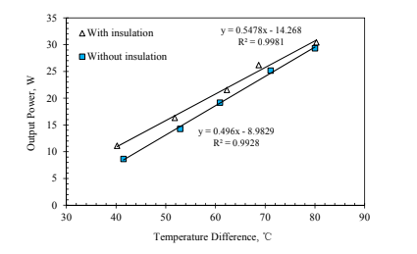

**Figure 2.3.1.1.** Output power with insulation and without insulation.

Clay, a very fine, grainy loose rock matter, becomes hard and stony when heated. Clay’s thermal conductivity, which is a property that indicates a material’s ability to conduct heat, is based on its water content. When the clay’s thermal conductivity gets low, it can serve many purposes. This can include being an oven for baking and drying or being an insulator where conservation of heat is needed within an area and heat loss by conduction is to be prevented (Folaranmi, 2009).

Fiberglass, a material found in most homes, helps with insulating heat and consists of multiple fine glass fibers. Fiberglass insulates heat by trapping pockets of air. This keeps houses warm or cold depending on the season (“What is Fiberglass Insulation? How it Works and What it’s Made of,” 2017). An experiment conducted (Wilkes & Childs, 1992) for fiberglass showed results of thermal resistance being inversely proportional to its temperature gradient. The results showed 35% to 50% less thermal resistance when the temperature gradient was high (70°F to 76°F).

### Cooling

The TEG’s hot side is usually in contact with a heat source. This heat source can be a waste heat pipe or concentrated solar radiation. Meanwhile, the TEG’s cold side is usually retained to low temperatures by using cooling methods. The different types of methods of cooling TEGs and their classifications are shown in the figure below (Kumar et al., 2019).

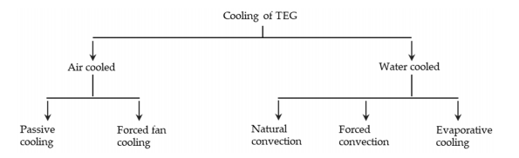

**Figure 2.3.2.1.** Schematic of an evaporative cooling system for TEG.

#### Passive Cooling

Passive cooling, which involves dispersing heat from the cold side to the air, is accomplished by natural convection. A study conducted (Dell, Thomas Petralia, Pokharel, & Unnthorsson, 2019) showed how a thermoelectric generator composed of six Laird thermoelectric modules, achieved an output of 6.9 W of steady state power with a 130 °C temperature difference. Ambient air cooling was selected as the setup’s cooling system.

Another study, also using a passive cooling system, showed that reducing the length of the heat sink while increasing the frontal area of the heat sink displayed that the TEG output power density improved by 88.70% (Wang, Hung, & Chen, 2012).

#### Water Cooling

For most of the existing thermal systems, including the TEG, water cooling is the most common method for cooling. Due to the abundance of water and its high threshold for heat capacity, water cooling is seen as appealing when choosing a method of cooling (Kumar et al., 2019).

A study involving Stove-powered TEGs (SPTEGs) made use of a water cooling system. Results showed an over 27 W electric power output generated with a temperature difference of 250 °C (Lv, Li, Zheng, Hu, & Li, 2018).

## Energy Storage System

Renewable sources generate energy that are usually first in electrical form. This generated energy can be either stored in mechanical, electrical, or electrochemical storage systems. The Electrochemical Energy Storage System, known as the Battery Energy Storage System (BESS), uses rechargeable batteries for energy storage. The Lead acid batteries, Alkaline (Nickel) batteries, Silver batteries, and Lithium batteries are the four major classifications of today’s rechargeable batteries (Ogunniyi & Pienaar, 2017).

A study (Dalala, Hamdan, Al-Taani, Al-Addous, & Albatayneh, 2019) which implemented battery storage system consisted of a TEG bank, a battery bank, a DC-DC boost converter, and a control circuit. The system is shown in the figure below.

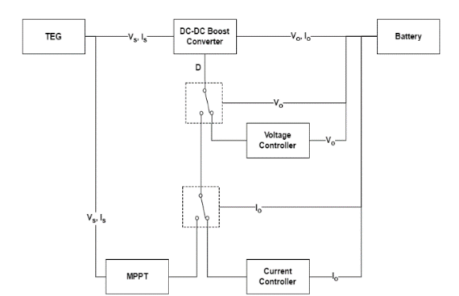

**Figure 2.4.1.** Proposed system block diagram

# 

# METHODOLOGY

This chapter focuses on the steps to be performed by the researchers to accomplished the task. The figure below presents the overview of the said steps. This chapter is divided into four sections: the first section describes the making of the charcoal pit model, the second section tackles on the integration of the TEGs into the setup, the third section shows the making of the energy storage system of the setup, and lastly, the section shows the development of the monitoring system consisting of the microcontroller and GUI in MATLAB.

Integration of TEGs to the setup

Making of scaled model of charcoal pit

Implementation of a Monitoring System

Development of an Energy Storage System

**Figure 3.1.** A flowchart representation of the major tasks in the study.

## Making of scaled model of Charcoal Pit

The researchers plan to three main components for the pit. First the use five hardiflex panels (0.5m x 0.5m) as the foundation and the base of the pit. Clay will then be used to coat the interior as thermal insulation to represent the actual depiction of the of the traditional way of making coconut shell charcoal. Lastly, fiberglass sheets will then be used as the outermost form of thermal insulation.

**Step 1:** The hardiflex panels are to be nailed together to form square pit. Also, two holes from each side (45mm x 45mm) are to be carved for the integration of the TEG to the setup.

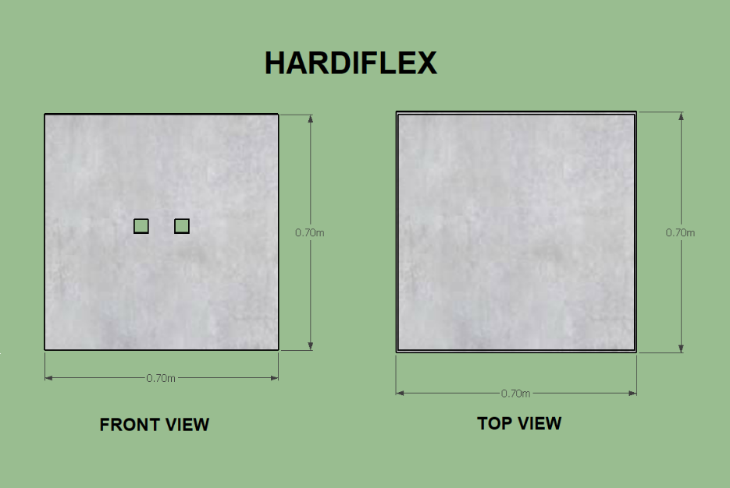

**Figure 3.1.1**. Step 1 representation of making of the scaled model

**Step 2:** The clay will be mixed with water to make a paste-like structure to make it stick to the interior side of the foundation of the setup. Similarly, the holes of the hardiflex panels will be left open.

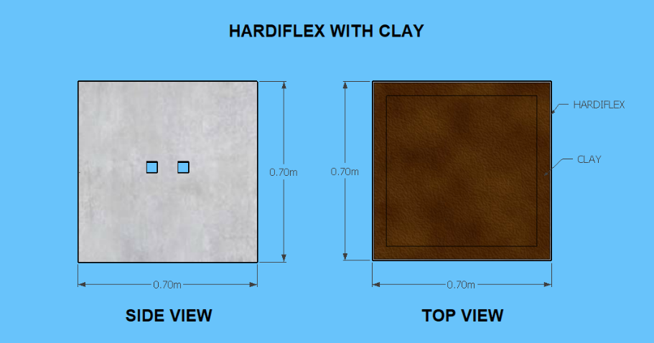

**Figure 3.1.2.** Step 2 representation of making the scaled model

**Step 3:** Lastly, the fiberglass sheets are to be used to cover the outermost layer of the hardiflex panels to further improve the thermal insulation of the setup leaving the holes made on the hardiflex panels exposed.

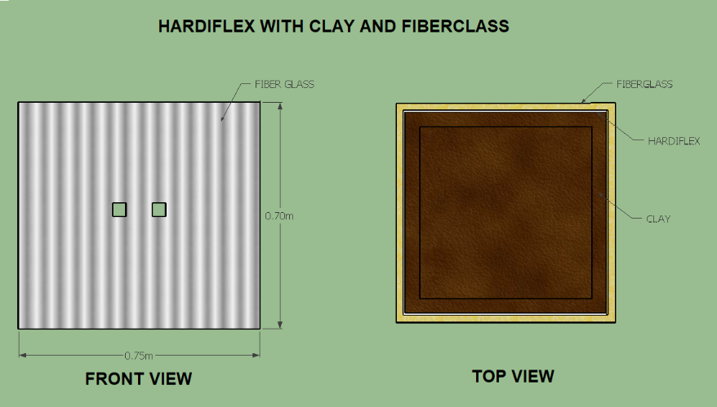

**Figure 3.1.3.** Step 3 representation of making the scaled model

## Integration of TEG to the setup

The researchers plan to use eight modules of TEGs (Model here) connected in series. As mentioned in the steps before, the TEGs are to be inserted into the carved holes of the hardiflex panels. High temperature resistant silicone rubber adhesive will be used to lock TEGs in place. The wires connecting TEGs to one another are to be wrapped in high temperature resistance tape to prevent damages from the heat.

### Cooling system of TEGs

Heatsinks are to be attached on both the hot and cold sides of the TEGs; this helps in the distribution of heat evenly. Thermal paste is to be used as an adhesive and to provide better conduction of heat to the TEGs. For the cold side of the TEGs, the researchers will rely on the ambient air of the surrounding for cooling purposes. The researchers believe that due to the general location of the traditional way of making coconut shell charcoal, being in the rural areas, the ambient temperature is sufficient for cooling.

## Development of an Energy Storage System

The output of the series connected TEGs are to be connected to a DC-DC converter. This is due to the nature of the setup where the voltage output of the TEGs is inconsistent. The inconsistency stems from the uncontrollable temperature difference of the TEGs. After the DC-DC Converter, a battery charger is connected to charge the final component of the system which is the battery. In between the battery charger and battery, a voltage sensor is connected in parallel while a current sensor is connected in series.

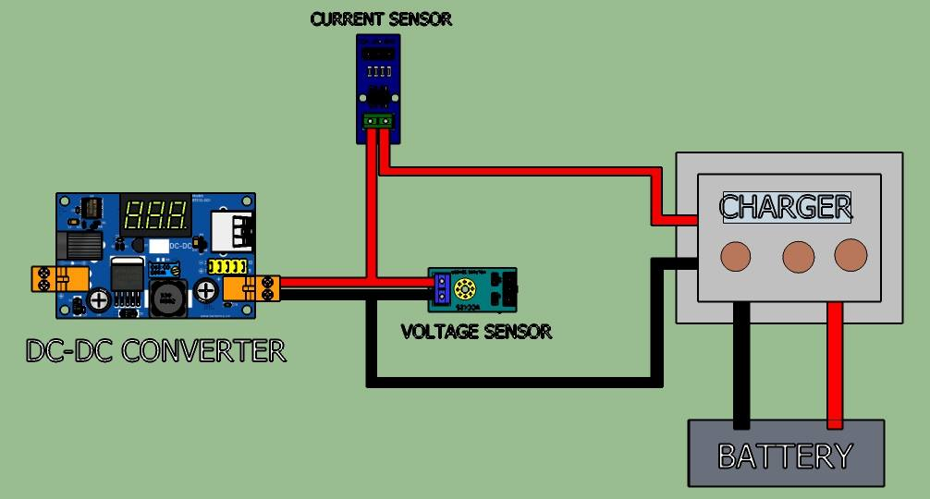

**Figure 3.3.1.** Proposed energy storage system of the setup.

## Implementation of a monitoring system

The researchers plan to make a monitoring system to observe the outputs of the system. The expected outputs, with the help of the voltage, current and temperature sensors, are the temperature of the TEG’s and the output power of the system.

### Microcontroller setup

The researchers, using an Arduino uno as a microcontroller, will be able to use the aforementioned sensors to collect data from the system developed. One temperature sensor, placed on top of the pit, will be used to acquire data to represent the hot side temperature of the TEGs. On the other hand, four temperature sensors are to be attached to each side of the pit for the cold side of the TEGs. The voltage and current sensors are connected to the output power of the battery charger of the energy storage system. All of these sensors will be connected to the Arduino for data acquisition. As shown in the figure below, shows the researchers overview of the microcontroller setup.

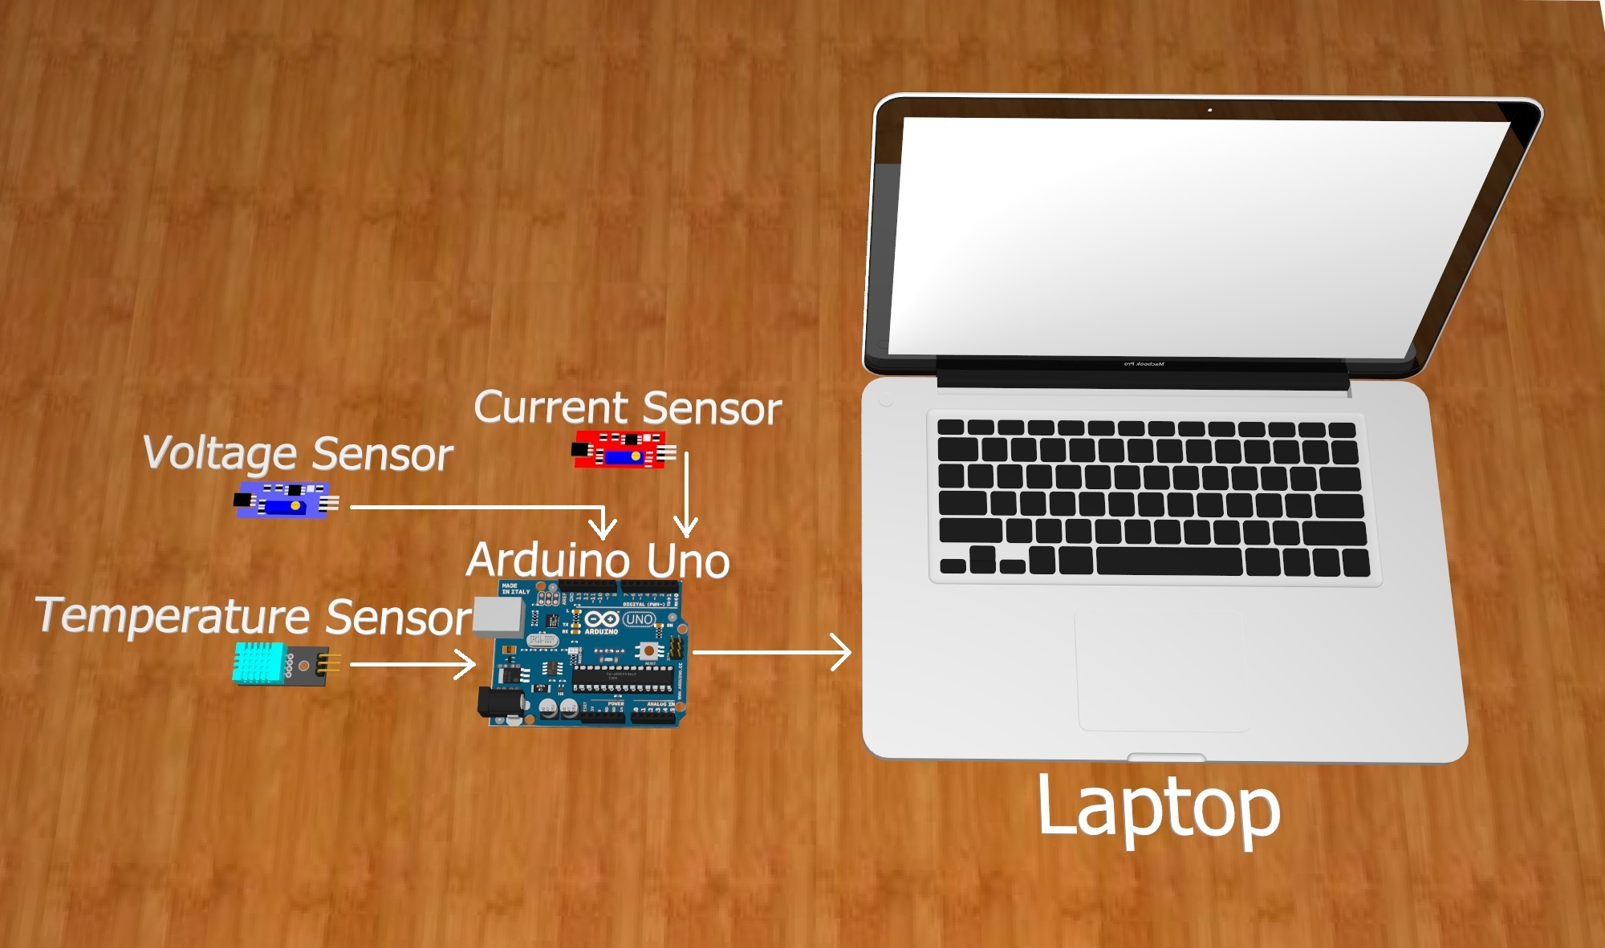

**Figure 3.4.1.1.** Proposed microcontroller setup.

### Software development

The researchers plan to develop a graphical user interface in MATLAB to present the data acquired from the microcontroller. The GUI will consist of a graph with four separate outputs for each of the sides of the pit for the temperature difference of the TEGs hot and cold side. The total output power of the system will also be graphed separately. All of the graphs will be presented with respect to time. The data acquired will also be saved in a file for documentation purposes. As shown in the figure below, the graphical user interfaced developed by the researchers.

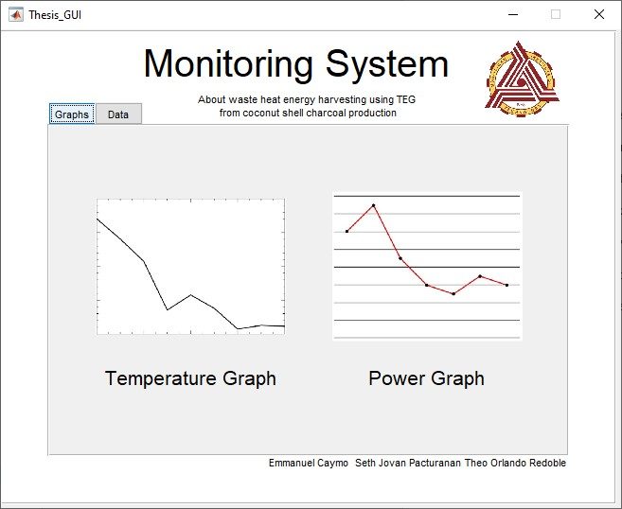

**Figure 3.4.2.1.** First panel of the GUI which shows the graphical outputs.

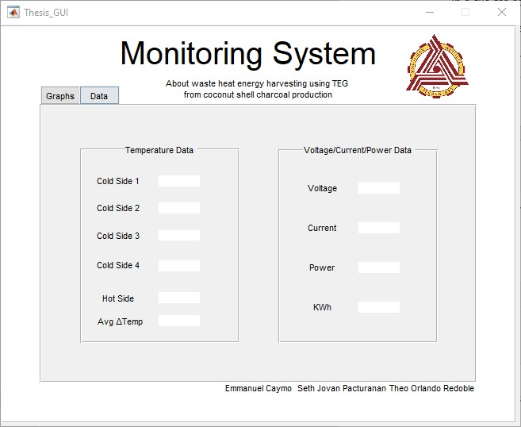

**Figure 3.4.2.2.** Second panel of the GUI which shows the data panel.

**BIBLIOGRAPHY**

2.36 million Philippine households without electricity: study - Xinhua | English.news.cn. (2017). Retrieved November 9, 2019, from http://www.xinhuanet.com/english/2017-09/29/c_136648509.htm?fbclid=IwAR1qNJ__HdRssMa2RBKv4pS5Jy1xBFQbjrXsvpZMwCq1VifbzaOuNGj1eLk

Ahiska, R., & Dişlitaş, S. (2011). Computer controlled test system for measuring the parameters of the real thermoelectric module. *Energy Conversion and Management*, *52*(1), 27–36. https://doi.org/https://doi.org/10.1016/j.enconman.2010.06.023

Awria, A., Albana, M. H., & Hakim, R. (2018). Experimental Study: Design of Thermoelectric Generator (TEG) Fixture for Harvesting an Automobile Electricity. *Proceedings of the 2018 International Conference on Applied Engineering, ICAE 2018*. https://doi.org/10.1109/INCAE.2018.8579151

Bensel, T. G., & Remedio, E. M. (2002). *Woodfuel Consumption and Production in the Philippines: A Desk Study*.

Budi, E., Umiatin, Nasbey, H., Bintoro, R. A., Wulandari, F., & Erlina. (2016). Activated coconut shell charcoal carbon using chemical-physical activation. *AIP Conference Proceedings*, *1712*. https://doi.org/10.1063/1.4941886

Dalala, Z. M., Hamdan, Z. S., Al-Taani, H., Al-Addous, M., & Albatayneh, A. (2019). Battery Charging Application with Thermoelectric Generators as Energy Harvesters. *The Academic Research Community Publication*, *3*(1), 248. https://doi.org/10.21625/archive.v3i1.446

Dell, R., Thomas Petralia, M., Pokharel, A., & Unnthorsson, R. (2019). Thermoelectric Generator Using Passive Cooling. In *Thermoelectrics for Power Generation [Working Title]*. https://doi.org/10.5772/intechopen.85559

DOE. (2016). ESAR. Retrieved November 9, 2019, from https://www.doe.gov.ph/sites/default/files/pdf/transparency/annual_report_esar_2016.pdf?fbclid=IwAR0iTg8OJzjOvbPJUwHER7fT2Wa9hk7X7rAYX2ZobWAa4zWNAfs4rWSjBR0

Emrich, W. (1985). History and Fundamentals of the Charcoal Process. In *Handbook of Charcoal Making* (pp. 1–18). https://doi.org/10.1007/978-94-017-0450-2_1

Fauzan, M. Y., Islam, S., Muyeen, S. M., Wardhana, A. S., Soedibyo, & Ashari, M. (2019). Experimental Modeling of Nano Power Generation using Thermoelectric Generator (TEG) from Incinerator Waste Heat. *Proceeding - 2018 International Seminar on Intelligent Technology and Its Application, ISITIA 2018*, 67–70. https://doi.org/10.1109/ISITIA.2018.8710874

Folaranmi, J. (2009). Effect of Additives on the Thermal Conductivity of Clay. *Leonardo Journal of Sciences*, *8*.

International Energy Agency. (2017). Database. Retrieved November 9, 2019, from https://www.iea.org/energyaccess/database/?fbclid=IwAR1XydeJYgncaz-t4qj8pgw6fIKYPoovU4Q18R6DxLYEcEEk0PxfWejXOFQ

Ishiyama, T., & Yamada, H. (2012). Effect of heat pipes to suppress heat leakage for thermoelectric generator of energy harvesting. *2012 International Conference on Renewable Energy Research and Applications (ICRERA)*, 1–4.

Ismail, B., & Ahmed, W. (2010). Thermoelectric Power Generation Using Waste-Heat Energy as an Alternative Green Technology. *Recent Patents on Electrical Engineering*, *2*. https://doi.org/10.2174/1874476110902010027

JFE Engineering Corporation. (2019). Waste Heat Recovery Power Generation System(Cagayan de Oro, Mindanao - The Philippines)｜JFE Engineering Corporation. Retrieved November 9, 2019, from http://www.jfe-eng.co.jp/en/foreign/int05.html?fbclid=IwAR3u_mYhlfmRyPz4q1YEkFdDKwrCIGOYi_aVtRo_WbCq5otYkpBL6GOzqHg

Jones, N. (2018). Waste Heat: Innovators Turn to an Overlooked Renewable Resource. *Yale Environment 360*.

Klinghoffer, N B, Themelis, N. J., & Castaldi, M. J. (2013). 1 - Waste to energy (WTE): an introduction. In Naomi B Klinghoffer & M. J. Castaldi (Eds.), *Waste to Energy Conversion Technology* (pp. 3–14). https://doi.org/https://doi.org/10.1533/9780857096364.1.3

Kumar, Babu, Subramanian, Bandla, Thakor, Ramakrishna, & Wei. (2019). The Design of a Thermoelectric Generator and Its Medical Applications. *Designs*, *3*(2), 22. https://doi.org/10.3390/designs3020022

Lv, H., Li, G., Zheng, Y., Hu, J., & Li, J. (2018). Compact Water-Cooled Thermoelectric Generator (TEG) based on a portable gas stove. *Energies*, *11*(9). https://doi.org/10.3390/en11092231

Ogunniyi, E. O., & Pienaar, H. C. V. Z. (2017). Overview of battery energy storage system advancement for renewable (photovoltaic) energy applications. *Proceedings of the 25th Conference on the Domestic Use of Energy, DUE 2017*, 233–239. https://doi.org/10.23919/DUE.2017.7931849

Skomedal, G. (2013). Thermoelectric Materials for Waste Heat Recovery. *University of Agder, Grimstad, Norway*.

Skomedal, G. (2016). *Thermal durability of novel thermoelectric materials for waste heat recovery*.

Sollesnes, G., & Helgerud, H. E. (2009). *Study of the potentials for the utilisation of excess heat from the Norwegian industry [In Norwegian: Potensialstudie for utnyttelse av spillvarme fra norsk industri]*. Retrieved from www.enova.no

Tang, Z. B., Deng, Y. D., Su, C. Q., Shuai, W. W., & Xie, C. J. (2015). A research on thermoelectric generator’s electrical performance under temperature mismatch conditions for automotive waste heat recovery system. *Case Studies in Thermal Engineering*, *5*, 143–150. https://doi.org/10.1016/j.csite.2015.03.006

Trip, N., Burca, A., & Morgos, L. (2017). *Considerations on the use of thermoelectric generators at low temperatures to recover waste geothermal energy*. 248–251. https://doi.org/10.1109/EMES.2017.7980426

Wang, C. C., Hung, C. I., & Chen, W. H. (2012). Design of heat sink for improving the performance of thermoelectric generator using two-stage optimization. *Energy*, *39*(1), 236–245. https://doi.org/10.1016/j.energy.2012.01.025

What is Fiberglass Insulation? How it Works and What it’s Made of. (2017). Retrieved November 9, 2019, from https://www.retrofoamofmichigan.com/blog/fiberglass-insulation-material-ingredients?fbclid=IwAR3u9JlhNSOc5869utp0t8Xjlt9GuyulYjx5Bq0spwrvlGQOmOTb3v-C1FE

Wilkes, K. E., & Childs, P. W. (1992). *Thermal Performanee of Fiberglass and Cellulose Attie Insulations*.